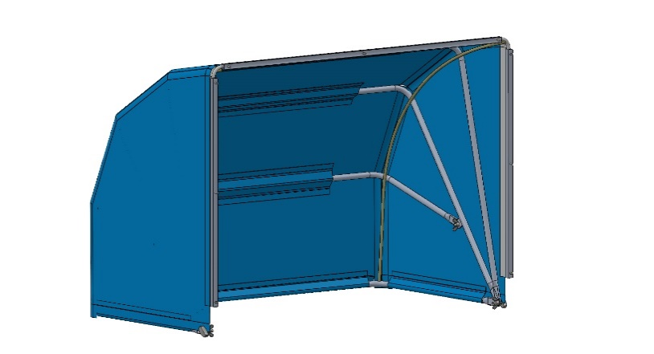
THERMO HOOD Installation Instructions

Tools Required for Installing the THERMO HOOD
- Cordless drill
- Cordless rivet gun

Scope of Delivery
- Foldable thermal hood on keder rails with side flange preassembled
- 4.0mm metal drill bit
- Stop collar
- 1 stainless steel hex angle keys
- 9 stainless steel blind rivets, 4mm


- 4 aluminum tube brackets
- 2 fiberglass tension rods (GRP) ø 6mm white,
with black end caps
- 4 carriage bolts M5 x 30mm
- 4 black plastic knurled nuts
- 2 stainless steel pipe clamps, 4A 12mm, preassembled
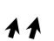
- 2 cable ties
- 2 two screws, for fastening the piping tape

THERMO HOOD Technical Data
High-tech microfiber:
Moisture-repellent, vapor-tight, tear-resistant, highly flexible, conditionally UV-resistant, dimensionally and temperature stable, double-stitched, rot-proof, food-safe.
- Color: Blue
- Design: Hood (foldable)
- Operating temperature range: -50°C to +70°C
- Tensile strength: 50 N/cm²
- Material thickness: 0.125mm (tolerance ± 0.025mm)
- Density: 1.8 m water column
- Weight: approx. 0.1 kg/m²
- Total weight including all components: approx. 2 kg

Microfiber Care
Polyester / polyamide, delicate wash cycle at 30°C (P)

Safety Instructions
When installing in cold storage and deep-freeze rooms, appropriate cold-protection clothing must be worn. Before installing a THERMO HOOD, a defrosting process must be initiated. Ensure that the cooler is completely free of frost and ice before installation.
Afterwards, disconnect the cooler from the electrical power supply and secure all components of the cooler against accidental restart. Failure to comply may result in danger to life.
For work that cannot be carried out from the ground, suitable work platforms are the best prerequisite for safe and professional installation.

Warning
During installation of the THERMO HOOD, wearing safety goggles is mandatory to protect the installer.

Installation of the THERMO HOOD
The THERMO HOOD is preassembled. First, check whether the flange dimensions of the THERMO HOOD match the mounting flange of the cooler. If they match, the upper flange of the THERMO HOOD, equipped with three holes, also serves as a drilling template.
First drill the center hole and then fasten the flange of the THERMO HOOD to the cooler using a 4mm blind rivet. After aligning the horizontal mounting flange, drill the remaining holes and create a permanent connection using the supplied blind rivets.

Safety Notice
The supplied drill bit with drill stop must not exceed a drilling depth of 10mm. Ensure that the stop collar is securely fixed against slipping using the set screw.
The vertical mounting rails of the THERMO HOOD may need to be adapted to the fastening points of the cooler’s side panels. Afterwards, the mounting rail of the THERMO HOOD can be fastened together with the side panel.
The foldable hood is then tensioned using the two fiberglass rods. To secure the rods, blind holes are provided within the 90° angles of the lowest aluminum tube bracket.
💡 Tip:
First insert the rods one after another into the designated holes. Then position the rods, including the rubberized end caps, under tension into the upper right and left corners against the mounting rail or against the keder strip.

Warning
The fiberglass rods must not rest against the flange of the cooler. Due to the permanent tension, the blind rivets would otherwise be subjected to unnecessary stress. The rods must rest against the mounting rail or the keder strip in order to relieve the load on the blind rivets.
👉 Note:
The fiberglass rods must be secured on both the right and left sides to the uppermost aluminum tube bracket using the supplied cable ties.
👉 Note:
The fiberglass rods are dimensioned to keep the hood permanently tensioned and must under no circumstances be shortened.
On both the right and left sides of the THERMO HOOD, the aluminum tube brackets are bundled together in a fan-shaped arrangement using carriage bolts. The knurled nuts must be tightened hand-tight only.
One aluminum tube bracket is attached with pipe clamps to one of the middle tube brackets and, if necessary, should be aligned and tensioned for shaping the hood. The knurled nuts here must also only be tightened hand-tight.

👉 Note:
If ‘SHUT UP’ and THERMO-HOOD elements are installed on a cooler, the following circuit configuration must be implemented. If the cooler block temperature exceeds the latent phase (ice-melting range) of +2 °C, the defrost heater must be switched off.
For the subsequent 10 minutes until the end of defrosting, the positive stored heat (residual heat) in the cooler block is utilised.
This utilisation of residual heat simultaneously serves as the drip-off time. The heat remains specifically within the cooler and remains available for the defrosting process.
The drip-off time should preferably be set to 10 minutes.
For cooling point controllers with an adjustable drip-off time, the delay-on-release time relay TR is not required. To ensure reliable defrost water drainage,
the
defrost water heater remains switched on via the K1 relay during the drip-off time until a cooling demand is received.
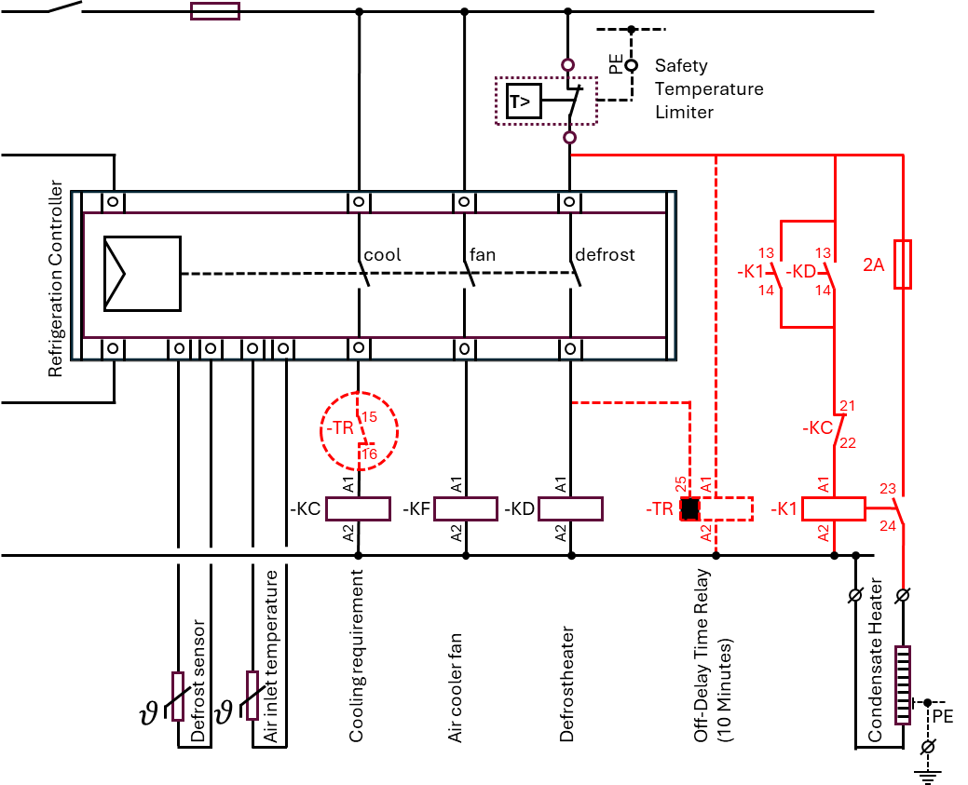
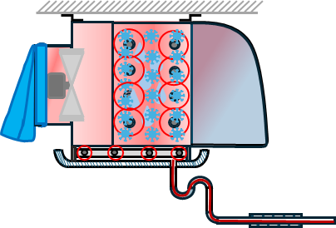

Simplified functional sequence (step-by-step)
1. The refrigeration controller requests a defrost cycle.
2. The defrost relay KD energizes.
3. Simultaneously, the cooling demand signal KC is switched off (KC de-energized).
4. Under these conditions, contactor K1 is actuated (via KD 13/14 and KC 21/22).
5. K1 energizes and subsequently maintains its state via the self-holding contact K1 (13/14).
6. The condensate drain heater is switched on via the power contact K1 (23/24).
7. At the end of the defrost phase, the refrigeration controller switches off the defrost heater.
8. Time relay TR starts its drop-out delay (approx. 10 min).
9. During this time, the condensate drain heater remains in operation (utilization of
residualheat).
10. Simultaneously, TR inhibits the cooling demand signal KC via normally closed contact
15/16. 11. After the time elapses, TR de-energizes. 12. Contact 15/16 closes again → cooling
operation KC is enabled. 13. Normal cooling operation resumes.
Functional description (technical documentation)
The condensate drain heater is controlled via a self-holding contactor K1, which may only be activated when a defrost request is active and the cooling demand signal is simultaneously switched off. K1 is actuated via a series connection of the normally open contact KD (13/14) of the defrost relay and the normally closed contact KC (21/22) of the refrigeration contactor. After energizing, K1 maintains its state via its auxiliary contact K1 (13/14). The load switching for the condensate drain heater is performed via the power contact K1 (23/24). To utilize residual heat within the cooler, a time-delay relay (TR) with a delayed-release function is employed. This relay is activated by the refrigeration controller once the defrost request is terminated and keeps the condensate drain heater energized for a defined overrun period (typically 10 minutes). During this delay period, the TR normally-closed contact (15/16) interrupts the enable signal to contactor KC, thereby preventing the refrigeration system from restarting during the drip-off and residual heat utilization phase. Once the set delay time has elapsed, the TR returns to its de-energized state and re-enables refrigeration operation via KC.

